Periodica Polytechnica
Electrical Engineering and
Computer Science

x(y) pp. x-x, (year)
https://doi.org/10.3311/PPee.XXXX
Creative Commons Attribution b
RETROSPECTIVE ARTICLE

Transistory: the 60-year-old Department of Electron Devices and the 70 year-old transistor
János Mizsei*, Vladimír Székely, Márta Rencz

Received xx Xxxx 201x, Online xx Xxxx 201x

Abstract
The transistor effect and the bipolar transistor are the most important discovery and invention of the last century. Inventors received a Nobel Prize soon after their revolutionary breakthrough in the field of solid state science and technology. However, their bipolar transistor has become obsolete by now, if we consider the total number of different operating devices all over the world. Today the most often used electronic components are (n/p channel) enhancement mode metal-oxide-semiconductor transistors, applied in complementer mode (CMOS). These are quite different in construction of the bipolar transistor and the operation principle also differs from the bipolar counterpart. Nevertheless, by taking a closer look, we can find many connections between them, especially in the basic role of the pn junctions, potential barriers and depletion layers and in the abstract description of their operation: both are modelled by controlled sources for the purpose of circuit simulation; representing their amplification feature and the non-reciprocal behavior in the overall embedding circuitry. The recent integrated circuits contain many billion CMOS gates realized on a silicon single crystal chip. As almost everyone owns several solid-state electronics based devices, instruments, such as personal computers, smart phones, household machines with some embedded intelligence, we can say without exaggeration, that the transistor is the device which has been produced in the largest number in the history of mankind. The main aims of this retrospective article are to summarize the 70 year development of the different kinds of transistors, and to give an overview of the development of our 60-year-old Department of Electron Devices.
Keywords
Transistor, bipolar transistor, MOS transistor, CMOS circuits, history, development of transistor technology, transistors in IC, future of the transistor, Department of Electron Devices

Department of Electron Devices,
Faculty of Electrical Engineering and Informatics,
Budapest University of Technology and Economics,
H-1521 Budapest, P.O.B. 91, Hungary (e­mail: mizsei@eet.bme.hu,
* Corresponding author, e-mail: mizsei@eet.bme.hu

Introduction
“Transistor” is an umbrella term nowadays, as nearly all three terminal semiconductor devices are called “transistor”. The word is coming from “transfer resistor”, which was how inventors, in the beginning, referred to their semiconductor amplifier element, which was the bipolar transistor. Other members of this large family are unipolar field effect type transistors: p/n channel enhancement/depletion type metal-oxide-semiconductor field effect transistors (MOSFET), junction field effect transistors (JFET).
The 60-year-old Department of Electron Devices of the Budapest University of Technology and Economics, Faculty of Electrical Engineering and Informatics is the only Department in the Hungarian higher education where research and education is carried out in all the fields of the theory, design, manufacturing and testing of semiconductor devices, in micro- and nanoelectronics, VLSI electronics, semiconductor sensors, energy transfer systems, microelectronic mechanical systems (MEMS) and systems in a package (SiP) and solid-state lighting. In the fields of Computer Science our specialities are Computer Aided Design in Micro- and nanoelectronics and internet based communication research.

Retrospection: the history of the “transistor”
In several early decades of the last century solid state physics went through a rapid development (see Fig.1). After the Second World War (WWII) there was high demand for a simple, cheap and low power consumption device to build a better and more reliable computer than the few existing ones based on electron tube technology, characterized by an MTBF (mean time between failures) in the order of magnitude of about an hour. The hot cathode in the electron tube was the main reason for this low reliability operation as well as for its high energy consumption.
The discovery of the “transistor” was hanging in the air, as earlier patents pointed out the possibility of the field effect controlled current.

Bipolar transistor
Bardeen and Brattain tried to investigate properties of the surface states by two electrical contacts on a grounded semiconductor crystal (Germanium) base. According to their notebooks [1], on Christmas Eve of 1947 they got a really beautiful present: their experimental arrangement started to work as a power amplifier. The official birthday of the point contact transistor is July the 1st, 1948 [2].
Point contact transistors were attractive components considering the low power consumption compared to electron tubes, and the relatively high cut off frequency because of low contact areas; however, their stability was not satisfactory. Also, the theory of these metal-semiconductor-metal devices was not completely clear. The next steps were clearing the theoretical basis of the p-n junction and the p-n-p junction transistor [3], and development of a fabrication method to produce a stable and reproducible device. The complete theory was also developed using the diffusion/transport equations and interaction of the forward biased emitter-base junction with the reverse biased collector-base junction.
The germanium based alloyed transistor was the dominant technology in the early phase of development. This technology resulted in poor quality devices because of the high temperature sensitivity of the base material (low bandgap energy germanium) and the lack of proper surface passivation. A lot of effort was devoted to improving the germanium transistor parameters, without remarkable success.
The real breakthrough solution was the silicon based epitaxial planar transistor with diffused base and emitter regions [4]. The higher bandgap energy and good quality SiO₂-Si interface resulted in lower saturation and leakage currents, higher temperature limit and properly passivated stable surfaces. Other characteristic features were the high emitter doping (resulting in high efficiency injection of minority charge carriers into the base), doping concentration gradient in the extremely thin base (characterized by a built-in electric field and low recombination loss, which result in high transport efficiency of the injected charge carriers), weak collector doping (high breakdown voltage) and high substrate doping below the epitaxial layer resulting in low collector series resistance. This transistor is widely known today as the “bipolar junction transistor” or BJT in short – the name reflects the fact the both the majority and minority charge carriers of adjacent p-n junctions play a role in the device operation. The technology of the silicon based epitaxial planar bipolar transistors led to the development of the bipolar integrated circuits. With this solid-state electronics was born, which later came to be known as microelectronics and is frequently called nanoelectronics today.

Unipolar devices
The idea of field effect based unipolar devices is older than bipolar devices [5], (see Fig.1). However, the amplifying field effect device could not have been realized because of the poor quality semiconductor raw materials available in the early days of solid-state electronics and high charge on the surface/interface states that screens the electrostatic field applied at the semiconductor surface from the conducting channel below that surface. The idea of the bipolar transistor emerged from research on surface states. The development of p-n and p-n-p junction theory to explain the bipolar transistor operation promoted the practical realisation of the unipolar field effect devices [6], see the yellow horizontal left-right arrows in Fig. 1. Further developments were based on the exact understanding of the near surface space charge layers [7] and the improvements in the semiconductor planar processing technology [8].
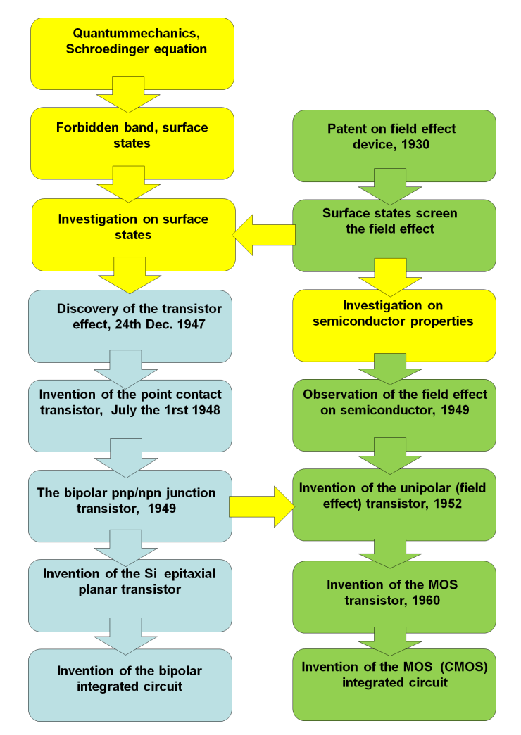
Discovery of the transistor effect, 24th Dec. 1947
Invention of the point contact transistor, July the 1rst 1948

Invention of the Si epitaxial planar transistor
The bipolar pnp/npn junction transistor, 1949
Invention of the bipolar integrated circuit

Invention of the unipolar (field effect) transistor, 1952
Patent on field effect device, 1930
Observation of the field effect on semiconductor, 1949
Surface states screen the field effect
Investigation on semiconductor properties
Invention of the MOS transistor, 1960
Invention of the MOS (CMOS) integrated circuit
Fig. 1 Milestones of the transistor history (yellow: basic research, blue: bipolar transistor, green: unipolar transistors)

The history of our department
In 1958, ten years after the revolutionary article [1] had appeared about the transistor effect, at the time of creating our department, mainly electron tubes or valves, aimed for different application fields, different frequency and power ranges were meant by the term electron devices. By then, at most European universities, education in the field of electron devices was carried out by departments which were mainly specialized in physics, telecommunications or electromagnetic theory, thus, education dedicated solely to electron devices was rare. The demand at TUNGSRAM Inc. (nowadays known as GE Lighting Europe) for specialized engineers, as well as the potential in this field of educuation, together triggered the creation of our department.
At that time TUNGSRAM was among the biggest light bulb and electron tube factories in Europe, thus students graduating at our department had good job opportunities either in manufacturing or research positions. TUNGSRAM had a strong and close relationship with our university, even before WWII a physics department of BME had been established with support by TUNGSRAM.
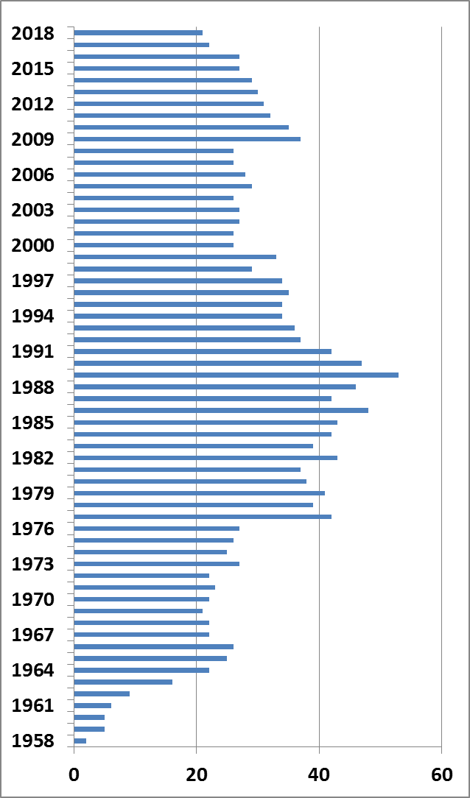
Discovery of the transistor effect, 24th Dec. 1947
Invention of the point contact transistor, July the 1rst 1948

Invention of the Si epitaxial planar transistor
The bipolar pnp/npn junction transistor, 1949
Invention of the bipolar integrated circuit

Invention of the unipolar (field effect) transistor, 1952
Patent on field effect device, 1930
Observation of the field effect on semiconductor, 1949
Surface states screen the field effect
Investigation on semiconductor properties
Invention of the MOS transistor, 1960
Invention of the MOS (CMOS) integrated circuit
Fig. 2 Number of employees at our department

Most R&D projects at our department were financed by TUNGSRAM, and the majority of our academic staff gained specific knowledge regarding electron devices directly at TUNGSRAM. The first head of department, prof. Iván Péter Valkó, who established the department, was originally a research engineer at TUNGSRAM, specialized in the construction of microwave electron tubes and measurement of electron tubes. He introduced the transistor in the curriculum of the “Department of Electron Tubes”. Soon the name of the department changed to “Department of Electron Tubes and Semiconductors”, and later to the more general “Department of Electron Devices”. After a rapid increase, the number of employees stabilised between 20 and 30 (see. Fig.2).
Investigation on surface states
Discovery of the transistor effect, 24th Dec. 1947
Invention of the point contact transistor, July the 1rst 1948

Invention of the Si epitaxial planar transistor
The bipolar pnp/npn junction transistor, 1949
Invention of the bipolar integrated circuit

Invention of the unipolar (field effect) transistor, 1952
Quantummechanics, Schroedinger equation
Forbidden band, surface states
Patent on field effect device, 1930
Observation of the field effect on semiconductor, 1949
Surface states screen the field effect
Investigation on semiconductor properties
Invention of the MOS transistor, 1960
Invention of the MOS (CMOS) integrated circuit
Starting from the second half of the 1960s, the role of electron tubes was taken over by transistors and other (discrete) semiconductor devices. This era is hallmarked at our department by the activity of prof. Kálmán Tarnay, who was Head of Department between 1977 and 1989. He introduced the teaching of computer programming and computer aided design of circuits and semiconductor devices in the curricula of the Faculty of Electrical Engineering of BME. The activities of both these professors were acknowledged by Dr.h.c. (doctor honoris causa) degrees of foreign universities and various honorary memberships of foreign scientific organizations.
In education, the laboratory practices related to technology underwent these changes: instead of pumping and closing down some electron tubes in the vacuum laboratory a double diffused bipolar transistor, and later a simple metal gate MOS integrated circuit were manufactured in our “not very clean room” at the semiconductor laboratory [9]. This practice was very special at that time, because it was not customary to allow students to enter into clean rooms that had to do with semiconductor technology. The broad scale of our activity required a higher number of employees, approximately 40-50.
In the second half of the 1980s, the Hungarian component manufacturing industry (including semiconductor devices) greatly declined, this is why enhanced co-operation with other educational institutes and research organizations became vital for us. This change in the history of our department is connected to prof. Vladimir Székely, Head of Department between 1990-2005. Vladimir Székely's research activity was first focussed on the study of transport phenomena in GaAs devices, study of electro-thermal phenomena and development of CAD tools for semiconductor devices and IC-s. Later his main interest was directed to the study of thermal problems in microlectronics. Under his leadership international co-operation of our department started flourishing, resulting in student mobility projects as well as in participation in numerous research projects supported by e.g. the European Union (TEMPUS, ESPRIT, COPERNICUS). For his outstanding scientific activity Vladimir Székely was elected corresponding member, and later ordinary member of the Hungarian Academy of Sciences. Our teaching programme was reformed to a large extent by the introduction of new subjects such as Integrated microsystems, Nanotechnology, Sensors and actuators, Optoelectronics, Physics of interfaces, Solar cells, etc. The number of employees stabilised at over 20.
The next Head of Department was prof. Márta Rencz, doctor of the Hungarian Academy of Science. Her various international achievements show that in the subsequent period the Department remained on the right track. During her leadership, in 2010 our department was relocated into a new facility, which offered a brand new laboratory. A new, truly clean room was set up in the new building which helps us teach the fundamentals of semiconductor processing technology, by way of fabrication of more sophisticated experimental devices, for example photovoltaic cells [10], etc. The department has gained in reputation for the designing of Cyber Physical Systems (CPS), and became the location of the first Digital Innovation Hub in Eastern Europe, supporting SMEs in CPS design [11].

Recent activities of our department
A special field of activity of the department is related to the multiphysical, especially thermal, electro-thermal, thermo-optical issues in Electronics, Micro- and Nanoelectronics. In this field, our department is one of the best known research centers worldwide. The Head of Department now is Dr. András Poppe, an internationally recognised expert at LED characterization and modelling.
Our mission today is to continue our high level research efforts as well as our educational activities in the above fields: to integrate the most recent scientific results in our curricula; and to involve, in the frames of the PhD programmes at our faculty, more young research engineers, among them more fresh graduates, in our scientific activities that are pursued in broad international cooperation.
A very successful field is the investigation of thermal problems of integrated circuits, thermal measurement and thermal design of ICs. Our world-wide reputation in this field was fostered by participation in many international research and development projects. We are proud to have been among the first to receive founding for our Framework 5 research project PROFIT. With partners such as Philips, Nokia, St. Microelectronics and Infineon, this has opened the door for us to the European microelectronics industry. The department became one of the main organisers of the THERMINIC conferences. There are numerous papers published by our department staff in this field. The first spinoff company of the department, MicReD Ltd., working in this field, became an international success, and now employs about 50 people at the MicReD unit of Mentor – a Siemens Business.

The main results of research in the thermal field are as follows:
- development of new algorithms for the simulation of steady-state and dynamic temperature distribution of IC chips; this work resulted in the research versions of the THERMAN and SUNRED simulation programmes,
- measurement of the surface temperature distribution of an operating integrated circuit, using liquid crystal coating,
- new measuring and identification method to determine the details of the heat-flow path of a semiconductor device (today also known as structure function analysis),
- CMOS temperature sensors suitable for inclusion into any digital IC, thermal monitoring, investigation of the principles and practical solutions for the built-in thermal monitoring of IC's and boards, connection with boundary-scan,
- development of the experimental version of an electro-thermal simulation package (SISSI) and a compact thermal model generator programme (THERMODEL),
- development of the thermal-electronic circuit (TELC) based on simple bulk type metal-insulator transition (MIT) devices.

Research on the characterisation of semiconductor surfaces and very thin oxides includes
- work function measurements on solid surfaces by vibrating capacitor (Kelvin) method,
- development of the scanning version of the vibrating capacitor method for surface potential, surface state density mapping of silicon wafers and the measurement of the light-induced surface potential transients on Si surfaces covered by ultrathin (tunnel) oxide
- investigation of catalytically activated semiconductor gas sensors, generation of olfactory images from the surface potentials measured on gas sensitive surfaces.

Our investigation and modelling of small-size and new semiconductor devices comprises
- Monte Carlo modelling of deep submicron MOS devices,
- development of circuit models for submicron MOS FET's,
- investigation of very thin (tunnel) gate oxide, new high-k gate dielectric and other tunnel-oxide devices,
- research and development of microfluidic chip based medical diagnostic devices.

Research into optoelectronics includes
- multiphysics characterization and modelling of LED devices
- reliability testing and modelling of LEDs,
- design of semiconductor optoelectronic integrated circuits,
- modelling of optoelectronic parameters of III-V semiconductor compounds,
- design of optical filters with quasi-periodic structures,
- simulation of composite cavity semiconductor lasers,
- development of new design tools for two-dimensional photonic bandgap systems.

Our research into media and system informatics field encompasses
- research of real-audio speaker's recognition and identification procedures,
- monitoring radio streams on the Internet,
- development of multimedia databases and information centres with platform independent interface,
- testing and monitoring the Linux server reliability.
Our recent activities related to IoT based solutions include
- research of digital and analogue low-power circuits,
- development of VHDL-based circuit synthesis methods, development of microprocessors and microcontrollers,
- R&D and practical implementation of cyber physical systems
smart biochemistry with dedicated micro-fluidic platforms.

The present and future of the transistor
Today’s microelectronics is based on complementer metal-oxide-semiconductor (CMOS) devices.
The convergence of the bipolar and field effect devices is obvious nowadays. Recent technology enables to integrate BJTs and MOSFETs onto the same chip (BiCMOS), and new discrete devices are emerging in power electronics, such as the insulated gate bipolar transistor (IGBT).
Transistors in scaled down CMOS work in the subthreshold region; there is only weak inversion below the gate. The recent MOSFETs still have a field effect character, but the transfer characteristics are not parabolic anymore, as the source-drain current depends on the emission over the gate controlled potential barrier, similarly to the operation of bipolar transistors.
The scaling down of the CMOS devices is accompanied by lower and lower power consumption of the individual transistors and lower supply voltages. As the previously discussed devices operate by electron emission over a potential barrier which is approximately half of the bandgap energy (0.5 eV for silicon), one can conclude that the supply voltage lower limit of deeply scaled CMOS ICs is about half a volt. This value can be decreased through replacing the emission over the potential barrier by the tunneling effect. The tunnel MOS is a really new and promising device [12]. It is similar to the conventional MOS transistor with strong source and drain doping, but the drain has opposite doping, and the bulk is near intrinsic, see Fig. 3. One of the ancestors of this structure is the gate controlled diode. This structure has been used to investigate the surface properties of semiconductors. Another ancestor is the tunnel diode. The tunnel emission results in higher drain current even at lower drain-source voltages, below 0.5 V.
This is just one example of the plethora of new devices (quantum-well transistor, spintronics, thermal-electronics, molecular electronics, graphene and carbon nanotubes, etc…) that will probably determine the next 60 years of Electronics, not to mention of strongly downsized devices that are needed for quantum electronics.

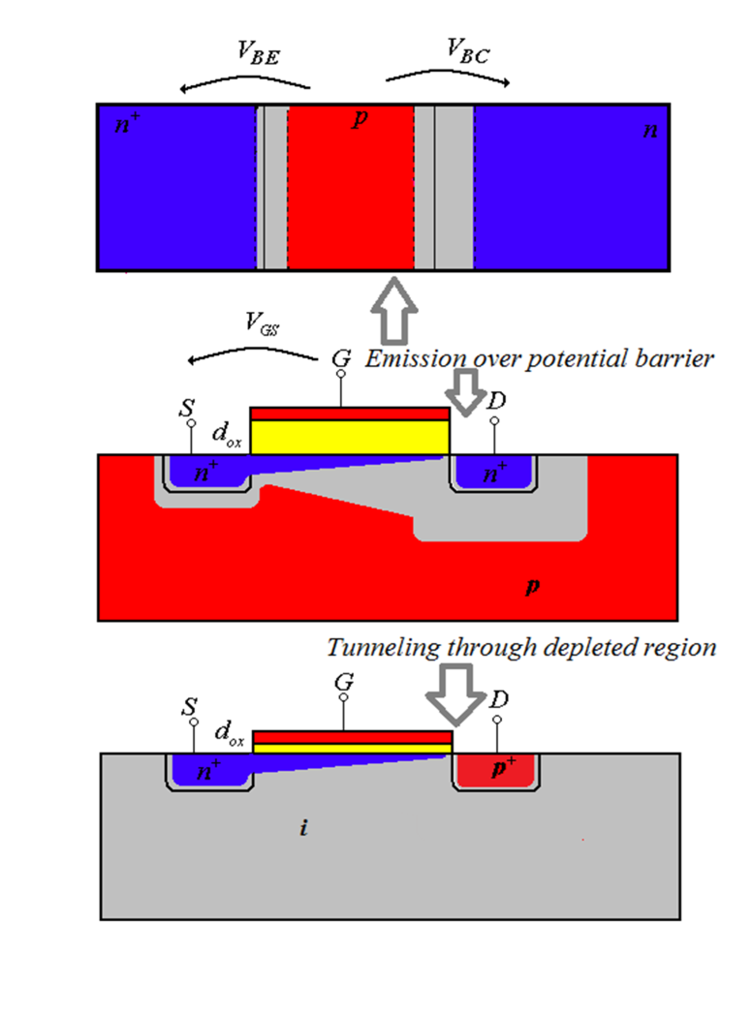
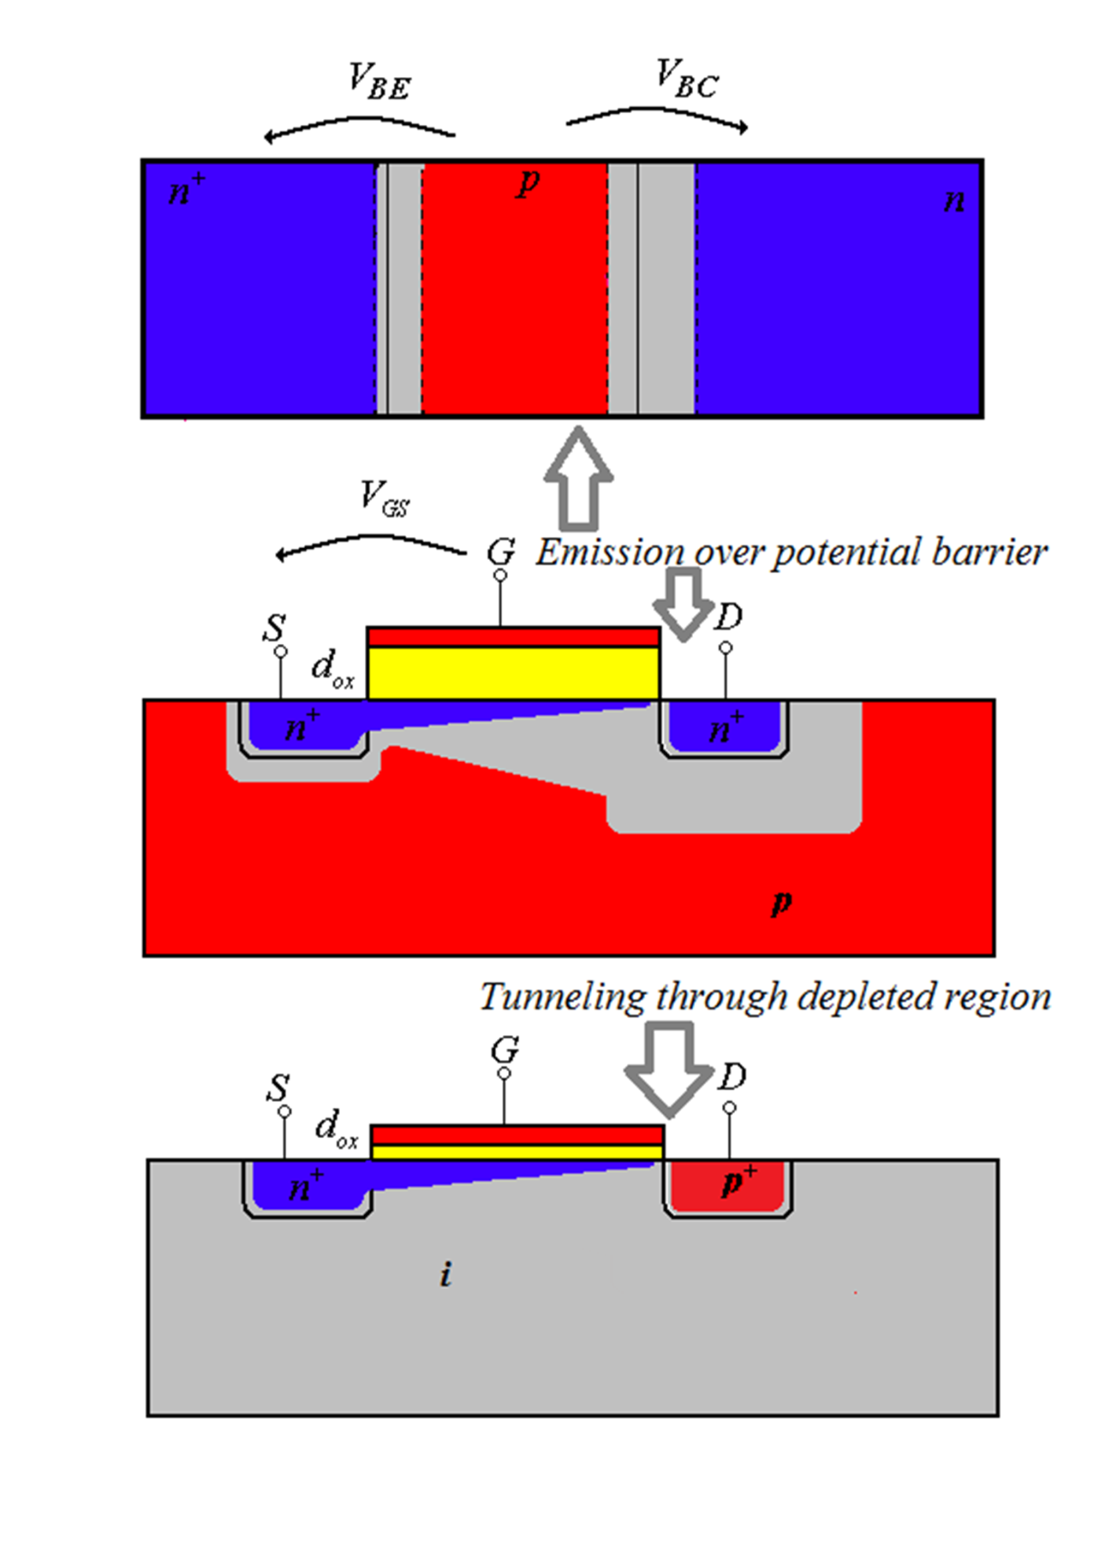

Discovery of the transistor effect, 24th Dec. 1947
Invention of the point contact transistor, July the 1rst 1948

Invention of the Si epitaxial planar transistor
The bipolar pnp/npn junction transistor, 1949
Invention of the bipolar integrated circuit

Invention of the unipolar (field effect) transistor, 1952
Patent on field effect device, 1930
Observation of the field effect on semiconductor, 1949
Surface states screen the field effect
Investigation on semiconductor properties
Invention of the MOS transistor, 1960
Invention of the MOS (CMOS) integrated circuit
Fig. 3 Shematic structure of the bipolar transistor, unipolar MOS field effect transistor and tunnel MOS field effect transistor (n type regions: blue, p type regions, metals: red, intrinsic or depleted regions: grey, oxide insulator: yellow)

Conclusion
There is no doubt that the transistor is the basis of our recent technical civilization. The long history of the field effect and bipolar transistor development highlights the importance of semiconductor science and technology. Considerable investment into that field resulted in an enormous development of integrated circuit technology. Results of this technology have spread in many different directions and promote a lot of innovation in the field of microsystems. Sensors, actuators, micromechanical devices have been developed and integrated with microcircuits, see for example in other articles of the current issue.
As the 60-year-old Department of Electron Devices and the 70 year-old-transistor develop parallel to each other, clearly the transistor wins when it comes to number of years of existence, but our department tries its best to keep the pace.

Acknowledgement
The research and collection of information presented in this article is supported by the various projects of the different framework programs of the European Union (FP5, 6, 7, H2020) and different national projects of the former Hungarian Scientific Research Fund (OTKA) including NN 110867 and recent national R&D projects funded by the Hungarian National Research, Development and Innovation Office (NKFIH).

References

[1] Weiner, C. “How the transistor emerged” IEEE Spectrum 10 (1973) 24 – 33.
DOI: 10.1109/MSPEC.1973.5219559
[2] J. Bardeen and W. H. Brattain “The Transistor, A Semi-Conductor Triode” Physics Rev. 74, (1948) 230-231.
DOI: 10.1103/PhysRev.74.230
[3] Shockley, W. “The theory of p-n junctions in semiconductors and p-n junction transistors” The Bell System Technical Journal 28, (1949) 435-489.
DOI: 10.1002/j.1538-7305.1949.tb03645.x
[4] Hoerni, J. A. "Planar Silicon Transistors and Diodes, IRE Electron Dev. Mtg., Wash., DC, Oct, 1960 JA Hoerni, Planar Silicon Devices and Transistors." Trans. Electron Devices, ED-8 178 (1961) 36-54.
[5] Lilienfeld, J.E. “METHOD AND APPARATUS FOR CONTROLLING ELECTRIC CURRENTS” US Patent 1,745,175 Jan. 28, 1930.
https://patentimages.storage.googleapis.com/fa/5d/33/ed2769d48fac4d/US1745175.pdf
[6] Shockley, W. and Pearson, G. L. "Modulation of conductance of thin films of semiconductors by surface charges," Physics Rev., 74, (1948) 232-233.
[7] Shockley, W. “A Unipolar "Field-Effect" Transistor”, Proceedings of the IRE 40, (1952) 1365 – 1376.
DOI: 10.1109/JRPROC.1952.273964
[8] Kahng, D. Attalla, M.M. “Si-SiO₂ field induced surface device” IRE Solid State. Dev. Res. Conf., Pittsburg, 1960.
[9] Timárné Horváth V. Harsányi J. Mizsei J. “Az integrált áramkörök technológiájának gyakorlati oktatása a BME Elektronikus Eszközök Tanszékén” Hiradástechnika: hírközlés-informatika 34 (1983) 499-503.
[10] Timár Horváth V. Mizsei J. Juhász L. “A new concept in solar cell related education at the Department of Electron Devices of the Budapest University of Technology and Economics”, In: V Benda (ed.) Proceedings of the 5th International Workshop on Teaching in Photovoltaics Prague, 2010.03.25-2010.03.26. (IWTPV'10). (ISBN:978-80-01-04532-9)
[11] See the EuroCPS project website at www.eurocps.org
[12] Alan C. Seabaugh Q. Z. “Low-Voltage Tunnel Transistors for Beyond CMOS Logic” Proceedings of the IEEE, 98, (2010) 2095-2110.

The historic term of “electron devices” is also maintained in the name of the IEEE Electron Devices Society which is active in the field of semiconductor devices and technologies.
Microelectronics Research and Development Ltd. Its abbreviated name MicReD® now is a registered trademark of Mentor – a Siemens Business.

