Analog Layout Exercise

Building a Simple Operational Amplifier

Introductory exercise for the MSc. course System Design Laboratory where detailed circuit and layout design has to be done for an analog circuit – mostly an operational amplifier (OpAmp), -- which was previously specified on system level,. This exercise demonstrates the basic steps of analog integrated circuit design and introduces the students to working with the design tool. The exercise, if well prepared, can be performed in the course of a 4 hours laboratory session. The participants are supposed to have a working knowledge of the Virtuoso Schematic Editor. (The preceding preparations include "getting familiar" with the task and after the session the final specification and documentation has to be done.)

Tool: Cadence 6

Technology: AMS 0.35µm

Dr. Peter Gärtner
Department of Electron Devices

25.01.2015.

Contents

1. The schematic diagram of the task 3
2. Preparation of the circuit diagram 3
3. Checking the properties by simulation 4
3.1. Prepare a symbol 5
3.2. Construction of the test-bench 5
3.3. Analyses by simulation 6
- DC transfer characteristics 6
- Common mode amplification 6
- Power supply rejection 6
- Bias-current sensitivity 6
- AC transfer characterristics 6
- AC transfer without phase compensation 6
- Quasi-static transient simulation 7
- Slew-Rate 7
4. Composing the data-sheet. 7
5. Preparing the floor-plan 7
6. Preparations of the layout-editor 9
7. Placement of the components 9
7.1. Coarse placement of the N-transistors 10
7.2. Positioning 10
7.3. Placement of the P-transistors 10
7.4. Placement of the feed-back capacitor 10
7.5. Specification of the guard-ring 11
7.6. Placement of the guard-ring 11
7.7. Closing the guard-ring 12
7.8. Preliminary DRC 12
8. Routing: making the connections 13
8.1. Connecting the gates on poly1 13
8.2. Completing the connection between T_{3A} and T_{3B} 14
8.3. Further connections, N-transistors 15
8.4. Further connections, P-transistors 15
8.5. Completing the routing, metal2 16
8.6. Placement of the pins 16
9. DRC 18
10. Extract 18
11. LVS 18
12. Post-Layout simulation 19
13. Complete the documentation 19
Appendix: Full layout of the OpAmp 21
1. The schematic diagram of the circuit is given.
The task is to design the layout of a simple two-stage OpAmp with phase compensation (Fig. 1.). The differential input consists of NMOS transistors – this determines the structure of the whole circuit.
U_{bias}
T₅
VDD
INP
I_{B}
OUT
INN
QN
T₂
T₁
T_{B}
T₇
T₆
T₄
T₃
QP
C_{V}

Fig. 1. The circuit structure of the OpAmp

Fig. 2. (next page) shows the detailed circuit diagram, developed by LTspice. The 8 kOhm resistor of the phase compensation is realized by the channel resistance of transistor T₈ because it occupies much less silicon area. The power supply is 3 volt. The quiescent current (operating point) is determined by an external bias current of 50 µA, provided at the pin UB.
In preparation for the exercise familiarize with the structure and operation of the circuit before the session. Estimate the node voltages and the branch currents. Consider different test-benches that could "ask questions" to the circuit which in response would deliver important specification data of the amplifier.

2. Prepare the circuit diagram.
Start Cadence6 (cog-wheel icon on the desktop). Establish a new library (File→New→Library) with a meaningful name referring to your project. All the cells defined in the project will be stored here. For the new library Cadence requests the specification of a technology. Select Attach to an existing technology library and in the window Attach Library to Technology Library specify TECH_C35B3. Open a new cell in the Library Manager (File→New→ Cell, view=schematic) and construct in this cell the circuit of Fig. 2. It is recommended to use the instance and node names of Fig. 2. Fetch the transistors n4 and p4 from the library PRIMLIB and the phase compensation capacitor CV has to be realized with the capacitance cpoly. Other components for the test-bench you should find later in the library analoglib.
Cadence does not use the multiplication factor mm. Instead, the instance name has to be formed as an array of two elements using the addition of <0:1> (e.g. T7<0:1>). The comparison of the schematic and the layout (LVS) can only work correctly if both networks, the netlist of the schematic and that extracted from the layout consist of strictly the same number of components.

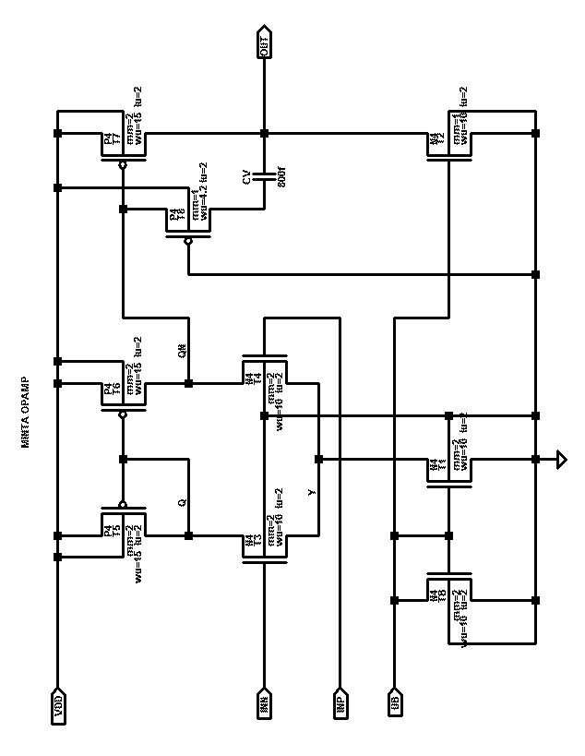
CX

Fig. 2. Circuit diagram of the amplifier
(drawn with the schematic editor of LTspice)

3. Checking the properties of the circuit by simulation
In this exercise the circuit is given. Its specification has to be determined by running detailed simulations. For this purpose a simulation environment has to be constructed.

3.1. Prepare a symbol.
The hyerarchical symbol (icon) has to be prepared, which enables the placement of an instance of the amplifier into the test-bench. This operation can be started from the Schematic Editor: Create→Cellview→From Cellview
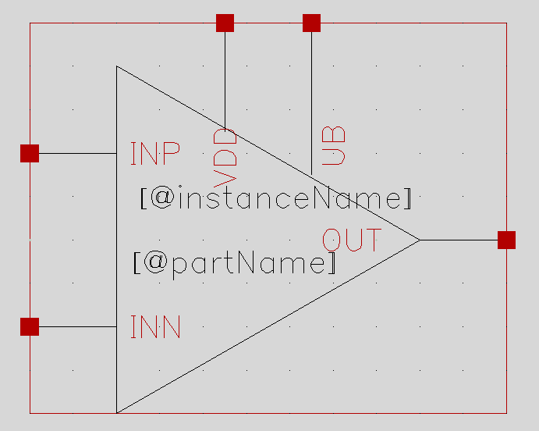
In the window which opens you have to specify From Schematic and To Symbol. The program offers the choise for the placement of the pins of the amplifier. The inputs should be on the left, the output on the right, and VDD as well as the bias current input UB on the top. The graphic symbol editor opens and the program automatically generates a rectangle-shaped symbol. However, the usual form of an OpAmp-symbol is a triangle. Therefore, the rectangle should be deleted from the drawing and a triangle should be made by the command
Draw→Shape→Polygon
Then the pins have to be adjusted to the triangle. The last step is the creation of the embordering rectangle by the command Create→Selection Box, in Automatic mode. Then, after saving, both windows of the Symbol Editor and the Schematic Editor can be closed. The program automatically stores the symbol in the library as a new view beside the schematic of the OpAmp (Fig. 3.).
Fig. 3. The symbol of the OpAmp
3.2. Construction of the test-bench.
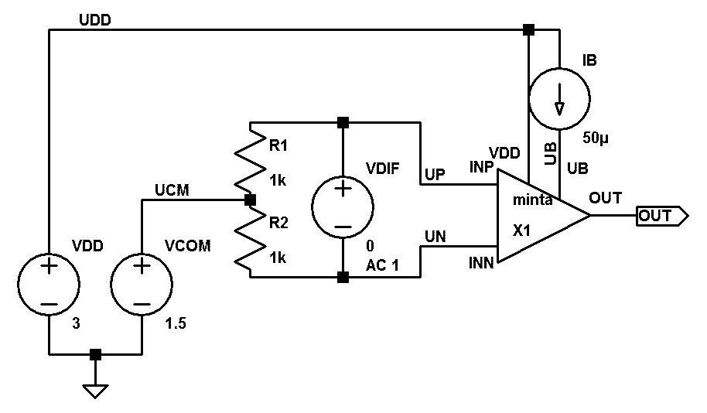
Open a new schematic cell in the Library Manager (File→New→Cell). The name of the new cell should be that of the OpAmp with a pre- or suffix of tb separated by an underscore. Using the command Create→Instance invoke the recently built icon and place it in the right half of the window. This is the first element of the test-bench. Further components have to be added

Fig. 4. The test-bench of the OpAmp.
In the first runs the sources are vdc and idc.
as it is shown in Fig. 4. using the same node-names. This is a universal test-bench circuit for studying the behaviour of circuits having differential inputs. This enables independent specification of differential as well as common mode input signals and performing almost all open-loop examinations with appropriately selected signal sources.
3.3. Analyses by simulation.
The recently completed test-bench is capable of performing four DC-sweep analyses without modifications. The Virtuoso Simulator has to be started from the Schematic Editor Window (Launch→ADE L). Invoke the mode-selecting window: Analyses→Choose…Here select DC mode, and in the field Sweep Variable activate the button Component Parameter. Returning to this very point you should analyze the dependance of the behaviour of the circuit upon the signals of all four generators.
- First of all analyze the differential transfer characteristics. The generator to be swept is VDIF. Write /VDIF into the field Component Name. The name of the parameter is dc. The voltage swing extends from -100µV to +100µV, the step is 1µV. Sweep Type has to be set linear. The specified simulation mode should be enabled by the button Enable and then a finishing OK closes the window. The next step is choosing signals for displaying. In the Virtuoso window activate Outputs→To Be Plotted→Select from Schematic. The Schematic Editor window comes up and you can select signals by clicking on the leads. Click on the OUT lead. The selection is acknowledged by changing the color of the lead. (A click on a terminal of a component selects the current flowing into the terminal and is acknowledged by a colored ring around the terminal. An inadvertent click can be undone by a second click on the same spot.) Return to the Virtuoso window. In the field Outputs the name of the selected node (pin) appears with the column Plot activated. Activate the column Save, too. Now the simulation can be started by clicking on the green spot on the left. After a successful simulation run the Waveform window opens with the differential transfer characteristics of the amplifier. Click at Marker→Place→Trace Marker to add a marker for the curve and add another one by clicking Marker→Add Delta. Set the markers to VDIF = ±10µV and determine the differential amplification factor.
- Similarly, study the common mode behaviour of the amplifier. In the Analyses field of the Virtuoso window activate the Choosig Analyses window. Change the sweeping generator to /VCOM. The voltage has to be swept from 1 to 2 volts with 1mV steps. Run the simulation. Then set markers to 1.4 and 1.6 volts and determine the common mode amplification factor (it is lower than 1!).
- Similarly, check the influence of the power supply, /VDD should sweep 2.5–3.5 volt.
- The last DC-sweep is the check of the output as a function of the bias current. The generator IB should be swept from 40µA to 60µA in steps of 1µA.
- With just a little modification you can use this test-bench to determine the AC transfer characteristics, too. Select the generator VDIF by a left click and depressing q invoke its property sheet. Write 1 in the AC field (unit AC input voltage) and give OK. Start the simulator Virtuoso and select AC simulation mode. In the opening fields specify the frequency range from 1Hz to 1GHz, in logarithmic mode, 30 points per decade. Activate the Enable button and give OK. Back in the Virtuoso window the simulation has to be started. The result will be displayed in the Waveform window, only the absolute value in linear mode. In the Virtuoso window activate Results→Direct Plot→Magnitude and Phase by a left click. The Schematic Window comes up with the schematic of the OpAmp. Select the lead OUT by a left click so its color changes. Now depress ESC. In the Waveform Window the Bode diagram appears, the amplification in dB and the phase linear.
- Now modify the value of the feed-back capacitor CV to 1fF (this is practically open circuit, the feed-back is switched off) and repeat the AC simulation at this setting. Compare the Bode diagrams and restore the original value of CV.
- The next analysis is a quasi-static transient simulation which gives a very good overview of the amplification properties of the circuit depending upon the common-mode input voltage. Put aside the present test-bench for later post-layout simulation. Make a copy of the test-bench (File→Copy…). Replace the added tb in the name of the new testbench by tran. Replace both simple vdc generators VDIF and VCOM by the type vpulse, also from the library analogLib. The common mode input voltage increases very slowly from zero to VDD. Select the generator VCOM by a left click and depressing q invoke its property sheet. Set the following parameters: beginning voltage 0V, max. voltage 3V. Delay 0, rise time 1sec, fall time 1sec, pulse width 50µsec, periode 2.1 sec. Onto this very slow changing voltage a much quicker but still slow small signal will be superimposed. Invoke the property sheet of VDIF and set the following parameters: beginning voltage -25µV, max. voltage 25µV. Delay 0, rise time 9µsec, fall time 9µsec, pulse width 1msec, periode 20msec. Now start the simulator and choose transient simulation. The length of the run should be 1 sec. For display select the output signal OUT and the common-mode input voltage UCOM. Run the simulation and zoom the time axis for the interval 400…600msec. Evaluate the results!
- Determine the Slew-Rate. This is done at strong overdrive of the amplifier. Restore the generator VCOM to the type vdc with constant 1.5V common-mode voltage. Set the VDIF puse generator to the followings: beginning voltage -2mV, max. voltage 2mV. Delay 0, rise time 0.1µsec, fall time 0.1µsec, pulse width 10µsec, periode 20µsec. The lengthof run should be 50µsec. Have the output OUT and the input UP displayed. In the Waveform Window separate the curves by activating Axis→Strips.
4. Composing the data-sheet.
From the simulation data prepare the data-sheet of the OpAmp containing the following specification data:
Power supply, bias current, current consumption (static),
Amplification factor at U_{COM}=V_{DD}/2,
Common mode rejection ratio CMRR (A_{DIFF}[dB]-A_{COM}[dB]),
Operating range of U_{COM}, (The "usable" range based upon the section g)
Power Supply rejection ΔU_{OUT}/ΔV_{DD}
Bias current sensibility ΔU_{OUT}/ΔI_{BIAS}
Frequency of the first (dominating) pole, f_{3dB}
Unity gain frequency f₁, phase margin Δφ_{m},
Slew Rate SR [V/µsec]
After the layout design the size of the cell will be added.
5. Preparing the floor-plan.
The first step is to make a scratchy placement of the components together with finding an optimal arrangement for the wiring.
T_{4A}
T_{4B}
T_{3A}
T_{3B}
In order to have transistors of identical characteristics the layout has to be composed using unit-transistors. In addition, the identicalness of the transistors of sensitive circuit parts can be enhanced by applying common centroid structures.
Fig. 5. Common centroid structure for T₃-T₄
In the schematics each transistor (except T₂ and T₈) consists of two units (the N- and P-channel transistors have different sizes). These can be constructed as double transistors turned to each other, having a common source. Their hight is, according to two channel length and the contacts, about 7-8µm. The width of N-transistors is 13-14µm, that of P-transistors is 18-20µm. The differential pair T₃ and T₄ will be built cross-coupled, as Fig. 5. shows them.
A sketch of the complete transistor arrangement is shown in Fig. 6.:
T₄
T₃
T₄
T₃
T₁
T₁
T_{B}
T_{B}
T₂
T₅
T₅
T₆
T₆
T₇
T₇
T₈

Fig. 6. The sketch of the transistors
The P-transistors will be placed in a common N-well. With this sketch the final floorplan with wiring can be designed. Fig. 7. shows it, in form of a stick-diagram-like sketch.
OUT
INN
INP
IB
CX

Fig. 7. The sketch of the complete floorplan
The sketch is self-explaining. METAL1 is blue, METAL2 is ocher. Black X is contact, purple X is via. Green is the active diffusion, dashed red line shows the N-well of the P-transistors. Printed in black-and-white the drawing is a little confusing, however, on a colored screen it is easy to overview. Guard-rings are not included, only the contacts of the N-well to VDD are marked. When the design will be finished, it will be engirdled by a P+ ring, connected to the ground. The differential inputs are furnished with a via bringing the connection to the layer METAL2 since they are blocked on the layer METAL1. The shape of the compensating capacitor CV has to be aligned to the width of the transistor block afterwards, and it will be connected to the nodes CX and OUT. (Remark: the sketch illustrates the principle that 20 and 30 µm wide transistors can be composed of 10 and 15 µm wide unit-transistors. In a "real" design even these should be halved using 5 and 7.5 µm wide unit transistors.)
6. Preparations of the layout-editor
Start Cadence. Select the name of the amplifier in the Library Manager. Left click File→New→Cellview. The New File window opens with the name of the amplifier entered. Set Type=layout and click OK. The Virtuoso Layout Editor opens with a new empty cell.
Before starting the work some settings have to be done. Left click Options→Display. In the field Display Controls set the number of displayed hierarchy levels (Display Levels) from 0 to 9 and activate the switches Pin Names and Instance Pins.
In the field Grid Controls set the size of the grid (X snap, Y snap) to 0.025µm and the Snap Mode in both cases to anyAngle. The editor accepts objects only at grid points. Since the minimum distance is 350nm, and a path is specified by its middle, for setting 175nm a grid of 25nm is necessary.
The settings have to be saved together with the cell. Switch on the buttons Cellview and Save To and click OK. Therefore, these settings will be automatically activated when the cellview will be opened later.
The Snap Mode determines the handling of objects with reference to the grid. It is worth-while changing it frequently when doing edition. By depressing <F3> a local menu opens for changing it. For instance, if you want to move an object horizontally. The grid is only 25nm and the mouse is uncertain, the object can slip a couple of vertical grids, too. So for this single action the Snap Mode can be set to horizontal and then the system will not allow any vertical movement.
Even so, exact positioning can be tiresome, but strong zooming can help. You can zoom in and out either using CTRL + mouse-wheel or selecting the area to be zoomed by a right drag. Then you can restore the previous display by typing w, or f for the full cell.
Switch on the display-control for the layers: Window→Assistants→Layers. In this window you can select the layer on which you want to create a shape. First set all layers for display. Later on, in an advanced situation you may want to display only the layers you are just working on. There are general switches in the upper part of the layout window:
- AV – all visible, all layers are displayed
- NV – none visible, only the activated (selected) layer is displayed
- AS – all selectable, shapes on each layer are selectable
- NS – none selectable, only shapes of the activated layer are selectable.
Display and selectability of shapes on a given layer can be controled one by one. This can be useful when you are working on shapes which are covered by shapes on other layers and only shapes on the uppermost layer can be selected. In such a case the "superfluous" layers can be temporarily switched off.
Switch on the continuous design rule check function.: in the menu item Options→DRD Edit set Interactive Mode to Notify. So the system will automatically check the most important (and easy to compute) rules and prompt with warning if they are violated when you are moving or drawing a shape.
Dimensions can be checked by the ruler function. After typing k you can create rulers with scale by a left drag between points of interests. Is the check/measurement done, the rulers disappear if you type (SHIFT+k). If the distance between two objects is given, you can draw a ruler from the existing one, showing where to place the other one.
7. Placement of the components. The placement is not independent of the wiring. Fig. 7. shows that the wires form the most dense web in the region of the differential pair (T₃ and T₄). Therefore, these transistors (each consisting of two units) have to be placed first, ensuring just enough room for the wires, too. This can be followed by the other N-transistors and then by the P-transistors. However, in this exercise, in order to simplify the task, the coordinates of the components are given in advance.
7.1. Coarse placement of the N-transistors. Let's begin with T₁. Left click Create→Instance. The Create Instance window opens. Click at Browse and find the cell nmos4 in the library PRIMLIB, set view=layout. The Create Instance window takes the form of the property sheet of nmos4, showing its parameters. The following parameters have to be set: Width=20u, Width Stripe=10u, Length=2u, Number of Gates=2. Switch on the Top and Bottom Contact and set Join Gates=no. Leave the other parameters at their default values. Click at Hide. The property sheet closes and the transistor comes up, linked to the cursor.
In the editor pane the axes of the coordinate system are white lines. Bring the transistor with its reference point in the lower left corner near the origin and place it there by a left click. The placement mode does not change, shifting the cursor you can place further instances of nmos4. In accordance with Fig. 7. place three more instances of the double transistor in a horizontal row, near to their final place. Then depress i for Create Instance and activate nmos4 for T₂: Width=10u, Width Stripe=10u, Length=2u, Number of Gates=1. This simple transistor should be placed at the end of the row.
7.2. Positioning. If the final coordinates (X and Y) are given then it is easy to do the final placement. Depressing <ESC> the placement mode is abandoned. At the left lower corner of the editor pane you can check that the mouse is again in its base (selecting) mode (mouse L: SingleSelectPt). Now the transistor can be selected by a left click. The selection is indicated by a dashed yellow (or white) line enclosing the contour of the transistor. Then evoke the Edit Instance Properties window by depressing q. Activate the tab Attribute. Here you will see the coordinates of the reference point and these can be modified as needed. Clicking OK the new coordinates will be finalized. In the lower row the final coordinates of the N-transistors are Y=0 and X=0, 12µ, 27µ, 39µ and 51µ.
7.3. Placement of the P-transistors. The P-transistors will reside in the second row above the N-transistors. Find the pmos4 transistor in the Create Instance window and set the common data of the transistors T₅, T₆ and T₇: Width=30u, Width Stripe=15u, Length=2u, Number of Gates=2. Then place them coarse in accordance with Fig. 7. followed by T₈ at the right edge with parameters Width=4.2u, Width Stripe=4.2u, Length=2u, Number of Gates=1. Now the P-transistors should be brought to their final place. The common Y is 10.5µ, while the X values are 0, 17.2µ, 34.4µ and 53.8µ.
The N-wells of the P-transistors will be extended to one common N-well. Select the layer NTUB in the Layers window. Activate the command Rectangle by depressing r. Zoom to the lower right corner of the N-well of T₈. and make here a left click. The common N-well begins here. Bring the cursor to the upper left corner of T₅ and set the coordinates X=-1.2µ and Y=18.75µ. Finish the rectangle here with a left click. (The left edge of the rectangle should coincide with the left edge of the N-well of T₅.)
7.4. Placement of the feed-back capacitor. The next component is the C_{V} feed-back capacitor. It is constructed by the layers poly1 and poly2 and you can find it as a parametrizable cell in the library PRIMLIB under the name cpoly. The parameters can be specified in the Create Instance window: Width=15.2u, Length=60.3u. The Ground Plane Right Contact as well as Top Plane Contact Middle switches have to be activated. (These data will deliver a good approximation of the needed 800fF.) The capacitor should be placed above the transistors and then set the final position: X=-2.05µ, Y=21.6µ.
7.5. Specification of the guard-ring. The capacitor is automatically enclosed in a guard-ring. It consists of a p+ diffusion, over it a grounded MET1 lead which is connected with the diffusion by a series of contacts. The placed transistors will also be enclosed by a similar guard-ring. Its upper side will be the lower edge of the guard-ring of the capacitor. The side-edges will continue those of the capacitor's downwards. The lower edge will be the ground lead which can be seen on the lower edge of Fig. 7.
For construction of the guard-ring first select MET1/drawing in the Layer window. Then left click at Create→Multipart Path. Depressing <F3> invoke the Create Multipart Path window (Fig. 8.). Beside the Multiple Part Path (MMP) Template select from the roll-down menu the structure pdiff_sub. (Behind it there is a hidden file which defines the details in TCL language.)
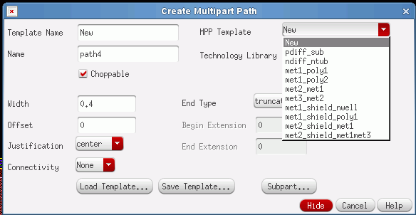

Fig. 8. Create Multipart Path window
After closing the window by activating the Hide button you can draw the guard-ring by left clicks just like a simple lead. At the end either make a quick double click or one click and then get out of the command by depressing <ESC>.
7.6. Placement of the guard-ring. The tactics is here, too, a coarse placement by the mouse and then refinement by numerical correction. Select the placed parts by a left click and then invoke the Edit ROD Multipart Path Properties window by depressing q (Fig. 9.).
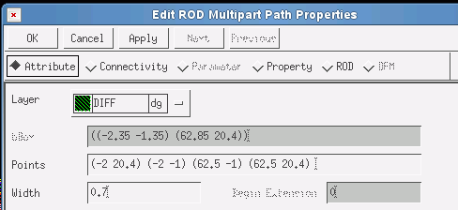

Fig. 9. Edit ROD Multipart Path Properties
Having activated the attributes (Attribute) the coordinates of the corner points (Points) appear. Because of the Manhattan-style construction, only one of the coordinates changes at the neighbouring points. Set the final coordinates: (-2 20.4) (-2 -1) (62.5 -1) (62.5 20.4). If you activate the changes by the button Apply then the window does not close. So, if necessary, you may correct values at once.
7.7. Closing the guard-ring. Zoom in to the left joint of the new guard-ring to the guard-ring of the capacitor with high magnification. In the Layer window MET1 is still selected. Switch off the display of the other layers by clicking at the button NV. Only the blue MET1 parts remain on the screen. You can see that the MET1 part of the multipart path is not connected to the guard-ring of the capacitor, there is a gap of 0.1µm. If it had gone up to abuttment then it would have generated a DRC violation at the contact windows. Therefore, you have to activate the Rectangle command (r) and fill in the gap with a MET1 rectangle: left click at the lower left corner and then at the upper right corner.
However, the situation is similar on the layer DIF, too. Click AV (all visible), select the layer DIF, and then NV for the other layers. Now fill in the gap of DIF like you did it with MET1. When finished, go to the other joint of the guard-ring and correct the gaps there, too.
7.8. Preliminary DRC. At this pointof the job "only" the connections are missing. Before doing that make a design rule check (DRC). Left click Verify→DRC. The DRC window opens. Click at Set Switches – the window of the same name opens, where you can set the parameters. Activate the switches no-coverage and no_erc because these checks are not relevant now. Clicking at OK the names of the switches appear in the DRC window. They remain there as long as the layout window stays open. In case of repeated checks you need not set them again (Fig. 10.).
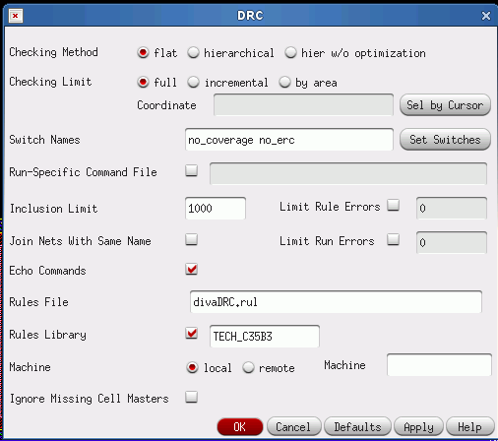

Fig. 10. DRC window
Giving OK the DRC is run. If there are violations they produce flashing white markers. Some violations may be small and difficult to perceive, therefore, it is better to have Virtuoso make a list and then zoom to them one by one. Left click Verify→Markers→Find – the Find Marker window opens. Here the Zoom To Markers button can be switched on and with next you can go to the violations one by one. For each fault an explanation appears in the Marker Text window.

8. Routing: making the connections. Connections are usually made by means of the instruction Path. First the layer of the connection has to be selected in the Layers window. Then the command Path is activated by depressing p. In default mode the width of the path is the minimum for the selected layer, the leads are laid in Manhattan style (horizontal and vertical). Depressing <F3> the property-sheet of the instruction can be activated and there the parameters can be modified. During this activity, and mainly if the place is not ample, it is advisable to make DRC frequently, because the sooner a violation is detected, the easier is to correct it.
8.1. Connecting the gates on poly1. If possible, gates are connected with each other on their own layer, using frequently the command Rectangle instead of Path. First of all both gates of the transistor T₁ should be connected with a 0.8µm wide rectangle. 0.8µm is wider than the minimum of 0.35µm, however, this is necessary for the contacts to be laid later. The length of the rectangle is aligned to the full width of the gates, about 5µm. Select poly1 in the window Layers. Zoom in the left edge of T₁. Depress r, then right click at the upper left corner of the upper gate, this will be the upper right corner of the rectangle. Move the cursor down and left to find the lower left corner of the rectangle. The lower edge of the rectangle has to be aligned to the lower edge of the lower gate (Y direction). The width of 0.8µm in the X direction can be set based upon the display of (dX,dY) which can be seen at the lower edge of the menu bar (Fig. 11.). Just left to them the position (X;Y) of the cursor can also be read.
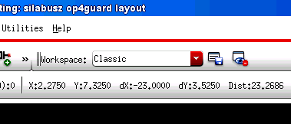

Fig. 11. Display of coordinates and distances
Details of the connection are shown in Fig. 12. In the upper part of the rectangle you can see the 0.8x0.8µm square for the would-be contact. The placement of the rectangle may happen to be inaccurate. Then you may correct it using the commands s (Stretch) and m (Move) at a strong zooming
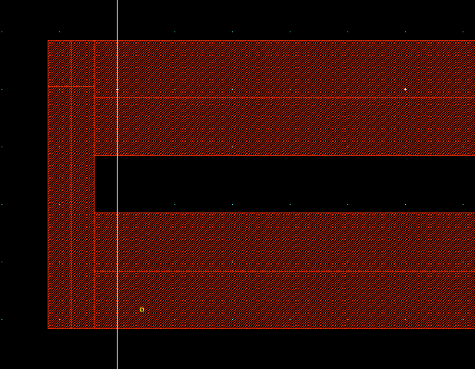

Fig. 12. poly1 rectangle at the left of the transistor T₁
You can do the other poly1 connections in similar manner:
- Connect both gates of T_{B} on the right. Then extend the gate of T₂ till T_{B}.
- Connect the gates of T₇ on the left.
- Place one rectangle between T₅ and T₆ which can connect all the gates there.
The connection of the gates of T₅ and T₆ is somewhat complicated for the leads cross each other. Place at the right of the gate of T_{3B} a horizontal rectangle, length 2µm, width 0.8µm, aligned to the middle of the gate. Similarly place another rectangle of the same size at the right of the gate of T_{4A}. Then place 0.8µm square at the left of the gate of T_{3A} aligned to the middle. Now connect the gates of T_{4A} and T_{4B} in two steps. First activate the command Path (p). As a default, the width of the path will be 0.35µm. Start from the middle of the gate of T_{4B}, bring it to the left 1.5µm. Turn it downwards by a click, bring it approximately to the hight of the middle of the gate T_{4A}. Finish it here by a quick double-click. Now close the gap with a 0.8µm wide rectangle which is aligned to the extension of the gate of T_{4A} as well as to the path (Fig. 13.). Check it by DRC not later than at this point (or earlier, too).
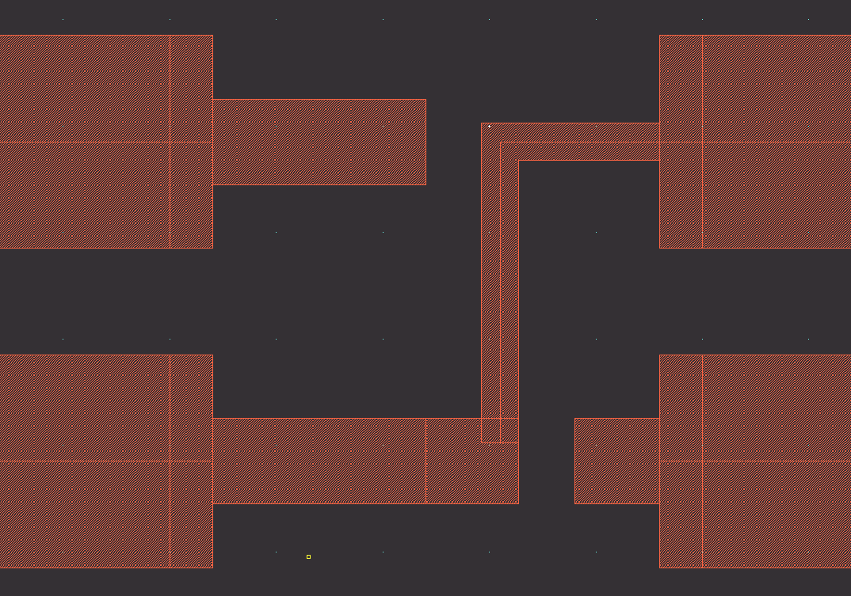

Fig. 13. poly1 connection between the gates of T_{4A} and T_{4B}
8.2. Completing the connection between the gates of T_{3A} and T_{3B}. This will be done combined with preparation of the inputs to the differential pair. First complete the surronding by connecting the sources by metal1. Select metal1 drawing and invoke Path. Lay a short horizontal path between the sources in the middle. Because of this piece of metal1 the connection of the gates has to be done on the metal2 layer with layer changes: poly1 → metal1 → metal2 and back to poly1. The next task is laying 3 poly1 contacts. Left click Create→Via. The Create Via window opens. At the Via Definition field select from the roll-down menu the poly1 contact: P1_C (Fig. 14.), everything else can remain default. Then click on Hide.
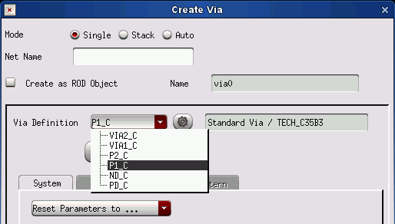

Fig. 14. Selecting the poly1 contact
The poly1 part of the contact is a 0.8µm square. It can be easily aligned to the right of the 2µm rectangles (from inside!) and onto the square at the gate of T_{3A}. You can place them by left clicks and then exit with <ESC>. Now you can go on with placing vias in order to get to metal2. In the Create Via window you have to select VIA1_C and place them. The X coordinate is 25.25µm for both, the Y's are 1.85 and 4.85µm. They have to be connected by metal2: select metal2 drawing, activate Path (p) and lay a vertical lead. The next step is connecting the vias with the poly1 contacts beside them on metal1. Select metal1 drawing and activate the Rectangle command (r). The upper via should be connected so that the height of the rectangle is aligned to the metal1 part of the poly1 contact. The lower rectangle has to be aligned to the metal1 part of the via and then formed so that it encases the metal1 part of the contact. Fig. 15. shows the result together with the results of the next two steps.
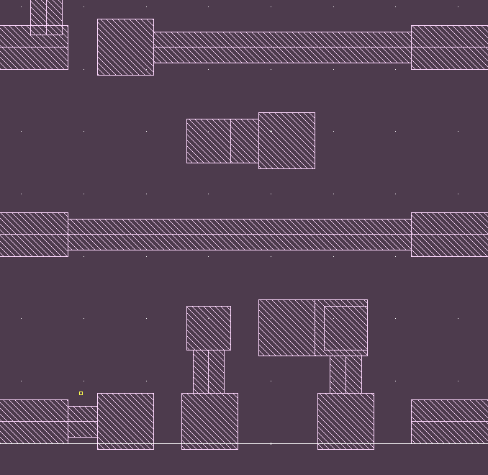

Fig. 15. Metal1 parts for connecting T_{3A} and T_{3B} and the inputs
Missing in this group are the connection of the drains of T_{4A} and T_{4B} as well as forming the input pins. Two vias are needed for the connection of the drains. X=22.675µm is common, the Y's are 0.35 and 6.35µm. When placing vias you should place two vias for the input, too. For them Y=0.35, common, X=24.025 and 26.2µm. Using the first two vias now you can connect the drains of T_{4A} and T_{4B} as it is shown in Fig. 7. then two short metal1 leads have to be laid from the gates to the second two vias. These vias are necessary for system-level connections because the inputs are accessible only on metal2.
8.3. Further connections, N-transistors. Lay down the following metal1 leads in accordance with the stick-diagram of Fig. 7.
- The source of T₁ left to the ground of the guard ring.
- The source of T_{B} downwards to the ground of the guard ring.
- The source of T₂ downwards to the ground of the guard ring.
- Connect the two drains of T₁ on the right and then connect them to the common sources of T₃ and T₄.
- Connect the drains of T_{3A} and T_{3B}.
- Connect the gate of T₁ with the gate and the drains of T_{B}. At both transistors place a contact on the poly1 rectangle which connects their gates. From the gate contact of T₁ lay a metal1 path till the lower drain of T_{B} including the gate contact, too. Then place a short lead from the upper drain of T_{B} to the path.
8.4. Further connections, P-transistors. The first step is the placement of the power rail (VDD). This will be aligned to the common N-well of the P-transistors. Place two well-contact aligned to the left and right upper corner of the well. Left click at Create→Via. Select ND_C in the field Via Definition and place vias at both corners. They have to be connected by a 0.7µm wide metal1 path. Select metal1 drawing, depress p and then <F3>. Set Width= 0.7µm and lay down the path. Afterwards return to the placement of well-contacts and place six more of them along the path.
In the followings continue with normal width (0.4µm) paths.
- Connect the common source of T₅ with VDD on the left side.
- On the right of T₅ and on the left of T₆ connect the drains of the double transistors with each other. T₅ is working as a MOS diode, therefore add a poly1 contact (P1_C) to the path over the gate.
- Connect the sources of T₆ and T₇ with each other and then connect them to VDD laying a short vertical path.
- On the right of T₇ connect the drains with each other.
- On the left of T₇ place a P1_C contact at the lower end of the rectangle connecting the gates. From here lay a metal1 path downwards and to the right until the lower electrode of T₈. (T₈ acting as a resistor, there is no need to distinguish between source and drain.) Connect the drain of T₆ to this lead, too.
8.5. Completing the routing, metal2.
- At X=22.675µm you have already connected the drains of T4_{A} and T4_{B}. Now continue the lead upwards aiming at the drain of T₆. Place a via at the same X direct beside the drain of T₆. Connect the metal2 lead to the via and go on with a metal1 path to the drain of T₆.
- Place a via on the lower corner of the lead, connecting the drains of T₅. From here lay a vertical metal2 path to the vicinity of the drain of T_{3B}. Place a via here and continue on metal1 to the drain of T_{3B}.
- The next step is to connect the drains of T₂ and T₇ and the lower electrode of CV. Place a via (V1_C) at X=51.7µm and Y=6.35µm. Connect it on metal1 with the drain of T₂. Lay a metal2 path upwards until Y=24µm. Lay a metal1 path from the lower corner of the lead connecting the drains of T₇ to the recently laid metal2 path and place a via here. Then place another via at the upper end of the metal2 path and go right to the metal1 connector of the lower electrode of CV.
- The last connection goes from the upper electrode of T₈ to the lower electrode of CV. Place two vias at X=55µm and Y=16.5 and 30µm. Lay between them a metal2 path. Then connect the vias on metal1, downwards to T₈ and to the left to the upper contact of CV.
8.6. Placement of the pins. The pins aare the terminals of the circuit for external connections. They must be identical with those on the schematics: the same name, same case (!) and direction. The only exception is the ground, represented in the schematics by the icon of the global gnd!, which automatically has the character of in/out. However, in the layout a regular pin has to be placed with the same name and with the property I/O Type=inputOutput. The pins will be placed onto metal1 leads. Their type will be rather pin than drawing. Activate the layer MET1-pin in the Layers window (Fig. 16.).
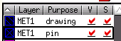

Fig. 16. Selecting MET1-pin
Now left click Create→Pin, so the window Create Shape Pin opens (Fig. 17. next page). Start with the node gnd!. Type the name and activate the Display Terminal Name switch. This is very important because without the display of the names the layout can work but the overview will be restricted. If you forget it, it cannot be modified later, the pin has to be deleted and newly placed. Activate the button Display Terminal Name Option beside the switch. It invokes the window Terminal Name Display (Fig. 18. next page) where the display of the name has to be specified. Here you have to set only that the name of the pin should appear on the text layer, which may be already the default. The window can be closed by clicking at OK.

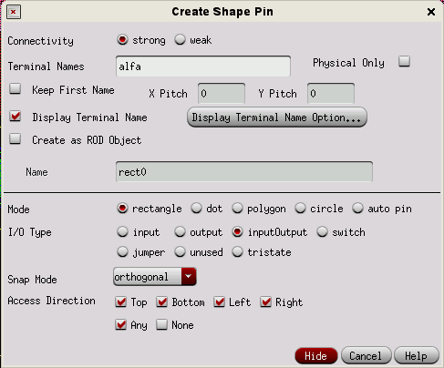

Fig. 17. Create Shape Pin window
Now in the Create Shape Pin window only the type of the pin has to be set. For gnd! switch on the button inputOutput, then click at Hide. The window will be closed and you can draw
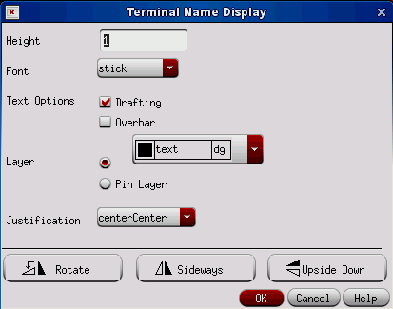

Fig. 18. Terminal Name Display window
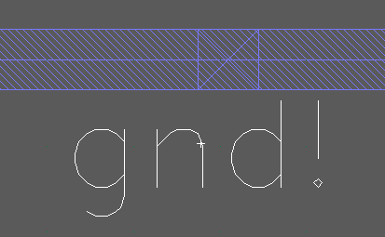
the pin in rectangle style. Near the lower left corner draw onto the metal1 lead of the guard-ring an aligning rectangle, possibly a square. After the second click the square is ready and the name of the pin appears – linked to the cursor. It has to be placed nearby with a left click. The result can be seen in Fig. 19, showing only the relevant layers. Following this place into the layout the four input pins: INP, INN, UB, VDD, as well as the only output pin OUT. Even if the room is limited, the input pins of the OpAmp can be placed on the short metal1 path between the via and the poly1 contact. Fig. 19. the gnd! pin
9. DRC. The checking of the design rules was already introduced in section 7.8 and it was advised that it should be executed after each critical step. Here it is only emphasized that before doing electrical verification the last step must always be a DRC. After the last DRC the cell has to be saved.
10. Extract. The extracting program analyses the drawings of the cell and generates a Spice netlist representing the graphic information in the cell. Left click Verify→Extract. The Extractor window opens. Activate the switch capall (Set Switches, Fig. 20.). So the parasitic capacitances, too, will be extracted and included in the netlist. They will be necessary at the post-layout simulation. After OK the extractor does the job and generates the extracted view of the cell OpAmp. The extracted view can be opened. It looks similar to the layout, and at strong zoom you can see the symbols of the extracted components beside the corresponding graphic elements.

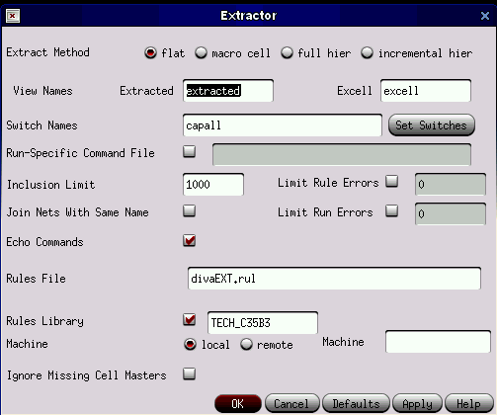

Fig. 20. ábra: Extractor window
11. LVS. Layout Versus Schematic – comparison of the original and the extracted netlists. This is the most stirring step of the layout design because it verifies whether the layout will really implement the network which was the origin of the design.
Open the extracted view. Left click Verify→LVS. The Artist LVS window opens (Fig 21, next page). Switch on in the row Create Netlist both schematic and extracted. Underneath you can invoke the library with the Browse and specify the cells to be compared – the extracted usually appears as default. The Rules File field remains empty, the Rules Library field atomatically gets the value TECH_C35B3. In the field LVS Options only the button Terminals has to be activated, all others remain switched off. Then start the comparison with the button Run. The process is running in the background and after a while a message appears. If it brings the eagerly awaited "The netlists match" then you may go on happily to the next task. However, the typical result of the first run is usually an error message. Then open the report file with a click at the button Outputs. In the report file LVS lists and explains the differences which have been found during the comparison. Then usually the layout has to be corrected and the LVS repeated.
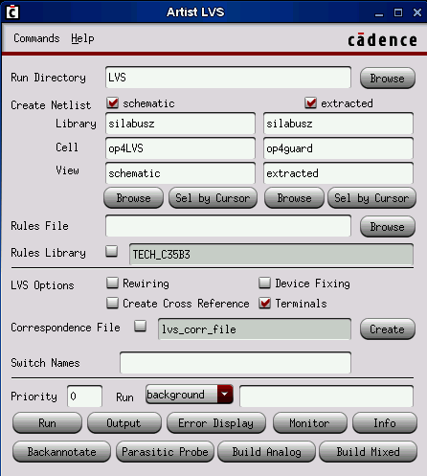

Fig. 21. Artist LVS window
12. Post-Layout simulation. The netlists match, the layout is correct. However, there are stray capacitancies which may influence the behaviour of the OpAmp more or less. So you have to check the final Bode-diagram of the OpAmp with the stray capacitancies included. Return to section 3.7.e). As a preparation repeat the AC simulation of the schematics. When the Bode-diagram appears on the screen stop the simulation and return to the settings.
In the simulation the netlist of the schematics has to be replaced by the extracted netlist of the layout, as follows. In the Virtuoso Simulator window left click on Setup→Environment. The Environment Options window opens (Fig. 22, next page). In the first row the content of the field Switch View List has to be extended so that you add the extracted view before the schematic. Close the window with OK. If you start the simulation now then it will deliver the post-layout results. Compare the results with those of the schematic, check whether there are differences.
13. Complete the documentation. The documentation of the OpAmp (catalogue data sheet) which was prepared according to section 4, should be finalized by adding the size of the cell. If necessary, modify the AC data based upon the results of the post-layout simulation.
In conclusion the Appendix presents the complete layout of the OpAmp, as the result of the exercise described in this leaflet.

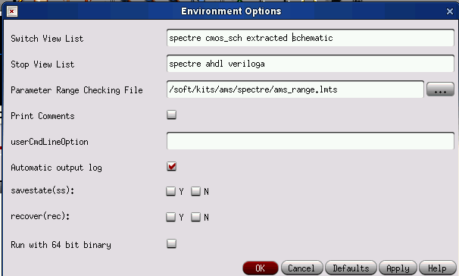

Fig. 22. Environment Options window

Appendix: Full layout of the OpAmp
