APPLIED PHYSICS LETTERS | VOLUME 78, NUMBER 8 | 19 FEBRUARY 2001

A single-electron inverter
C. P. Heij, P. Hadley, J. E. Mooij
Applied Physics and DIMES, Delft University of Technology
Lorentzweg 1, 2628 CJ Delft, The Netherlands
A single-electron inverter was fabricated that switches from a high output to a low output when a fraction of an electron is added to the input. For the proper operation of the inverter, the two single-electron transistors that make up the inverter must exhibit voltage gain. Voltage gain was achieved by fabricating a combination of parallel plate gate capacitors and small tunnel junctions in a two-layer circuit. Voltage gain of 2.6 was attained at 25 mK and remained larger than one for temperatures up to 140 mK. The temperature dependence of the gain agrees with orthodox theory of single-electron tunneling.
The use of single-electron tunneling devices for computation has been widely discussed because these devices can be made very small and they consume relatively little power. [1,2] A variety of single-electron device logic schemes have been put forward but relatively few of the proposed single-electron logic elements have been tested experimentally. Here measurements on a single-electron inverter are presented. The inverter is a fundamental building block of single-electron transistor logic, which bears considerable resemblance to standard semiconductor CMOS logic. [3,4] The logic levels are represented by voltages and a small number of electrons are transported when the inverter switches from the high state to the low state. The logic gates NAND and NOR can be realized by making slight variations of the inverter circuit. With two inverters, a static RAM memory cell can be constructed and a ring oscillator can be made from three inverters. Voltage gain is essential for many of these circuit applications but thus far gain has been achieved in relatively few devices. [5,6] The inverter discussed here has voltage gain.
A scanning electron microscope (SEM) photograph of the device and a schematic diagram of the inverter circuit are shown in Fig. 1. The inverter consists of two nominally identical single-electron transistors (SET's) in series that share a common input gate. Each single-electron transistor used in this inverter contains a small aluminum island with a total capacitance C_{Σ} = 1.6 fF. The SET's are outlined with dotted lines in the schematic. The input of the inverter, V_{i}, extends under the two islands. The input is electrically isolated from the two islands by an 8 nm thick layer of aluminum oxide. This forms the two input capacitors C_{i1} and C_{i2}. The output V_{o} is connected to ground via an on-chip load capacitor C_{L} of 130 pF to suppress charging effects at the output. The output is also coupled to the two islands via small tunnel junctions. The power lead, V_{b}, and the grounded lead are similarly connected to the islands via small tunnel junctions. The two tuning gates, V_{g1} and V_{g1}, are used to tune the induced charges on the two islands.
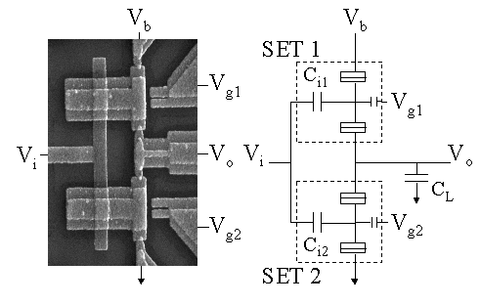
Fig.1. On the left is a scanning electron microscope image of the inverter and on the right is the corresponding schematic. The width of the T-shaped islands is 1 μm. The dotted lines outline the two SET's in the circuit. The load capacitor C_{L} is not shown in the SEM photo.
For inverter operation, the output should be high when the input is low and the output should be low when the input is high. This is achieved by applying a bias voltage of V_{b} = e/C_{Σ} = 100 μV and adjusting the two tuning gates such that when the input voltage is low, the top transistor is conducting and the bottom transistor is in Coulomb blockade. This effectively connects the output to the supply voltage and makes the output high. The Coulomb blockade prevents a steady current from flowing through the inverter limiting the dissipation in this device. When a high input voltage is applied, this shifts the induced charge on each of the SET's by a fraction of an electron and puts the top transistor in Coulomb blockade and makes the bottom transistor conducting so that the output is effectively connected to ground. Thus, when the input is high, the output is low.
The device was fabricated on a thermally oxidized silicon substrate using a high-resolution electron beam pattern generator at 100 kV. Each layer of the circuit was defined using a double layer resist and was aligned to prefabricated Pt markers. The bottom layer of the circuit consisted of a 25 nm thick aluminum film that was patterned to form the lower electrodes of the gate capacitors and the load capacitor. To form the dielectric for the capacitors, the sample was heated to 200ºC and the aluminum was oxidized in an O₂ plasma at 100 mTorr for 5 minutes. The resulting Al_{x}O_{y} layer was 8 nm thick. A second aluminum film was then deposited in a pattern that defined the islands and the leads. The four tunnel junctions were defined in this layer by shadow evaporation.
The device was measured in a dilution refrigerator with a base temperature of 25 mK. All leads were equipped with π-filters at room temperature and copper-powder filters at base temperature. Superconductivity was suppressed using a 1 T magnetic field. Measurements on the individual SET's revealed that the tunnel junctions were all identical with capacitances of C_{j} = 280 aF and resistances of 1.1 MΩ. The input capacitances were C_{i1} = 800 aF and C_{i2} = 810 aF, the tuning gate capacitances were 45 aF, and the stray capacitance of each island was estimated to be 190 aF.
Figure 2a shows the dependence of the output voltage on V_{i} and ΔQ, the difference between the induced charge on both islands. The induced charge difference can be controlled by adjusting the two tuning gates V_{g1} and V_{g2}. This figure illustrates that the input-output characteristics of the inverter can vary greatly depending on the voltages applied to the tuning gates. In the region around ΔQ = e, the output is a weak function of the input. When the tuning gates are adjusted so that the induced charges are e/2 out of phase, there are large oscillations of the output voltage as the input voltage is varied. Increasing both of the tuning gates simultaneously leaves ΔQ constant but has the same effect as increasing V_{i}.
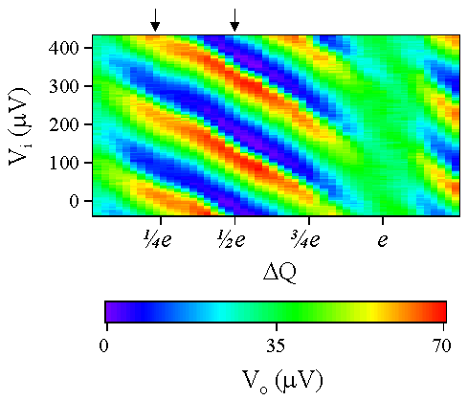
Fig. 2. The output voltage of the inverter is plotted in color as a function of the input voltage and the induced charge difference between the two islands. The arrows indicate where the data for Fig. 3 was extracted from Fig. 2.
Figure 3 shows input-output characteristics at 30 mK for two different values of ΔQ. The arrows in Fig. 2 indicate where the data for Fig. 3 was extracted. Note that when the input voltage is low, the output voltage is high and when the input voltage is high, the output voltage is low. To achieve this input-output characteristic, the gate voltages were adjusted manually. At this point there is no procedure known for automatically tuning the gate voltages on-chip for the optimal inverter performance. This is probably the largest problem inhibiting the further development of this sort of logic.
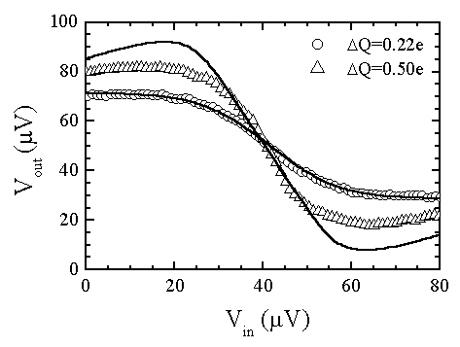
Fig. 3. The input-output characteristics of the inverter are plotted for two values of the induced charge difference. The solid lines are simulations using the orthodox theory for single-electron tunneling.
The solid lines in Fig. 3 are simulations of the inverter characteristic calculated at 30 mK using the orthodox theory for single-electron tunneling. For the most part the orthodox theory fits the measurements. The largest deviations occur at ΔQ = e/2 and either minimal or maximal output voltage. At ΔQ = e/2 the maximal observed output voltage swing is 75% of what is expected from orthodox theory. This can be due to external noise coupling in via the leads. The device is most sensitive to external noise at these bias conditions.
An important consideration for the proper operation of an inverter is that the maximum output voltage swing must be greater than the voltage swing necessary at the input to switch the output from low to high. In other words, the inverter must exhibit voltage gain. The maximum voltage gain that can be achieved in a single-electron transistor is the ratio of the input-gate capacitance to the junction capacitance g_{v} = C_{i}/C_{j}. In this work, overlap capacitors were used to make relatively large input-gate capacitors. The maximum voltage gain of the inverter, which can be determined from the slope of the transitional region in Fig. 3, was g_{v} = 2.6.
Figure 4 shows the gain of the inverter as a function of temperature. Note that a voltage gain greater than one is only attained for temperatures below about 140 mK. This is the highest temperature for which voltage gain in a single-electron transistor has been achieved. While there have been many reports of single-electron transistors operating at room temperature, those transistors typically have a voltage gain much less than one. Gain is difficult to achieve at high temperatures because the gate capacitance must be made larger than the junction capacitance while making the total capacitance small. Fabricating a room-temperature single-electron transistor with voltage gain is challenging because it almost certainly requires control of the fabrication process on a nanometer scale in three dimensions.
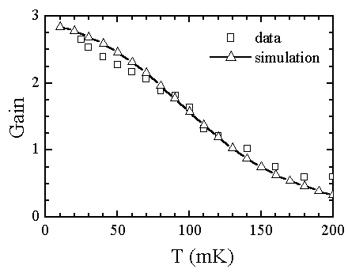
The gain of the inverter is plotted as a function of the temperature. The gain decreases below one at 140 mK. The expected temperature dependence of the gain was simulated using the orthodox theory for single-electron tunneling.
The measurements on this single-electron inverter show that it can operate as it was designed to and that the orthodox theory adequately describes the behavior of the circuit. The voltage gain necessary for the operation of this inverter was achieved by using overlap capacitors in a multilayer circuit, yielding a maximum gain of 2.6 at 25 mK.

[1] For an overview of Single-electron devices and their applications, see: K. K. Likharev, Proceedings of the IEEE 87 606 (1999).
[2] Yu. A. Pashkin, Y. Nakamura, and J.S. Tsai, Appl. Phys. Lett. 76 2256 (2000).
[3] J. R. Tucker, J. Appl. Phys. 72 4399 (1992). [4] A. N. Korotkov, R. H. Chen, and K. K. Likharev, J. Appl. Phys. 78 2520 (1995).
[5] G. Zimmerli, R.L. Kautz, and John M. Martinis, Appl. Phys. Lett. 61 2616 (1992).
[6] C. P. Heij, D. C. Dixon, P. Hadley, and J. E. Mooij, Appl. Phys. Lett. 74 1042 (1999).

